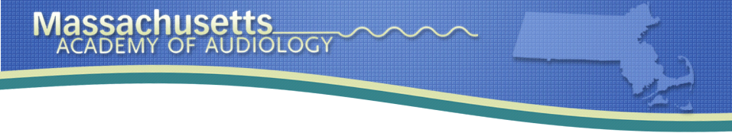

April 15, 2019

Dear Friends of the Massachusetts Academy of Audiology,

On behalf of all the board members for the Massachusetts Academy of Audiology, we are pleased to invite you to participate in our 2019 Fall Convention. This year’s event will take place at the Crown Plaza Hotel in Natick, MA on Friday, September 20, 2019. We are pleased to announce that Dr. Natalie Phillips, Senior Audiologist with Advanced Otolaryngology and Audiology in Fort Collins, Colorado and the CEO of Connect4Excellence will be a featured speaker. Donald Schum, PhD, VP of Audiology at Oticon, USA will be presenting on “The Future of Connected Hearing Healthcare”.

Our goal for this year’s convention is to continue to offer our members outstanding continuing education programs and networking opportunities. Our membership continues to grow, and in our 13th year as an organization, we currently have over 100 members.

This year we are asking our sponsors to support us through our various sponsorship levels. These levels are available on a first-come, first-served basis. The levels of support include:

- Platinum sponsorship
- Gold sponsorship
- Silver sponsorship

The 2019 sponsorship program highlights include a range of opportunities offering maximum exposure at the 2019 Convention, including recognition at the convention, web site and print advertisements and much more. A description of these levels is available on the corresponding document attached.

We are also looking for silent auction items from our sponsors and exhibitors. All proceeds help us to continue to develop program offerings for our membership.

In order to take advantage of sponsorship opportunities, please email (massachusettsacademyofaudiology@yahoo.com) or mail your completed forms back to the Massachusetts Academy of Audiology by June 30th, 2019.

Sponsorship Opportunities for MAA
Platinum | Gold | Silver
- Acknowledge the different level (platinum) in our event brochure | - Acknowledge the different level (gold) in our event brochure | - Acknowledge the different level (silver) in our event brochure
- First selection of booth space for exhibitors | - Second selection of booth space for exhibitors | - Booth provided for exhibitor
- Most prominent ad banner on MAA website | - Premiere ad banner on MAA website | - Ad banner on MAA website
- “Thank You” banner as Platinum contributor on easel display in lobby of exhibitor space to MAA | - “Thank You” banner as Gold contributor to MAA | - “Thank You” banner as Silver contributor to MAA
- Verbal acknowledgment of Platinum support at opening remarks during annual meeting; Platinum sponsor allowed a two-five minute remark/introduction | - Verbal acknowledgement of Gold support at opening remarks | - Verbal acknowledgement of Silver support at opening remarks
- Provides any supplemental giveaways for annual convention, including logo bags, logo pens, logo folders and other items
- Offer to allow a speaker from the manufacturer’s group to speak at MAA annual meeting (not on product)
- Only one Platinum sponsor per year | - Only 4 gold sponsors per year | Unlimited silver sponsors
$5000 or more | $2500-$4999 | $1000-$2499

Name of company_________________________________________

Sponsorship level__________________________________________

Sponsorship amount________________________________________

Name of representative(s) in attendance during conference___________________________________________________

Contact Person’s Name, Email and Phone Number_________________________________________________________________________________________________________________________________________________________________________________________________________________

Please indicate if you will need an outlet available for your table by checking here__________

The booth charge of $500 is waived for all participating sponsors at the Platinum, Gold and Silver levels.

Please send this completed form by June 30th, 2019 via email to massachusettsacademyofaudiology@yahoo.com or mail to:
MA Academy of Audiology
PO BOX 320649
Boston, MA 02132

Please make all checks out to Massachusetts Academy of Audiology.

